HACCP template for inulin
- Product introduction
Product Name: Inulin
Product Definition & Composition: A functional polydisperse carbohydrate consisting of linear fructosyl units, primarily extracted from plant sources such as chicory roots or Jerusalem artichokes.
Target Consumer: Suitable for the general population, particularly those seeking high-fiber, low-sugar, or low-fat dietary options in dairy, bakery, and functional food sectors.

- Processing Method
The production begins with the preparation of raw materials, where chicory roots or Jerusalem artichoke tubers are cleaned, washed, and sliced into cossettes to optimize extraction efficiency. Inulin is then extracted through either conventional continuous counter-current hot water diffusion (70-80°C for 1-2 hours) or non-conventional green technologies such as Pulsed Electric Fields (PEF) and Ultrasound-Assisted Extraction (UAE) to enhance yield and reduce thermal degradation. The resulting extract undergoes a multi-stage purification process, including liming and carbonation to precipitate impurities, activated carbon treatment for decolorization, and cation/anion exchange resins for demineralization. Following refinement, the purified juice is concentrated via vacuum evaporation and subjected to $0.2$-$\mu\text{m}$ membrane filtration to ensure microbiological sterility. The final product is achieved through spray drying to form a stable powder, which is immediately packed into moisture-proof food-grade containers to prevent caking and maintain its structural integrity throughout distribution.(See Fig.1).
- Process Flow diagram (待定)
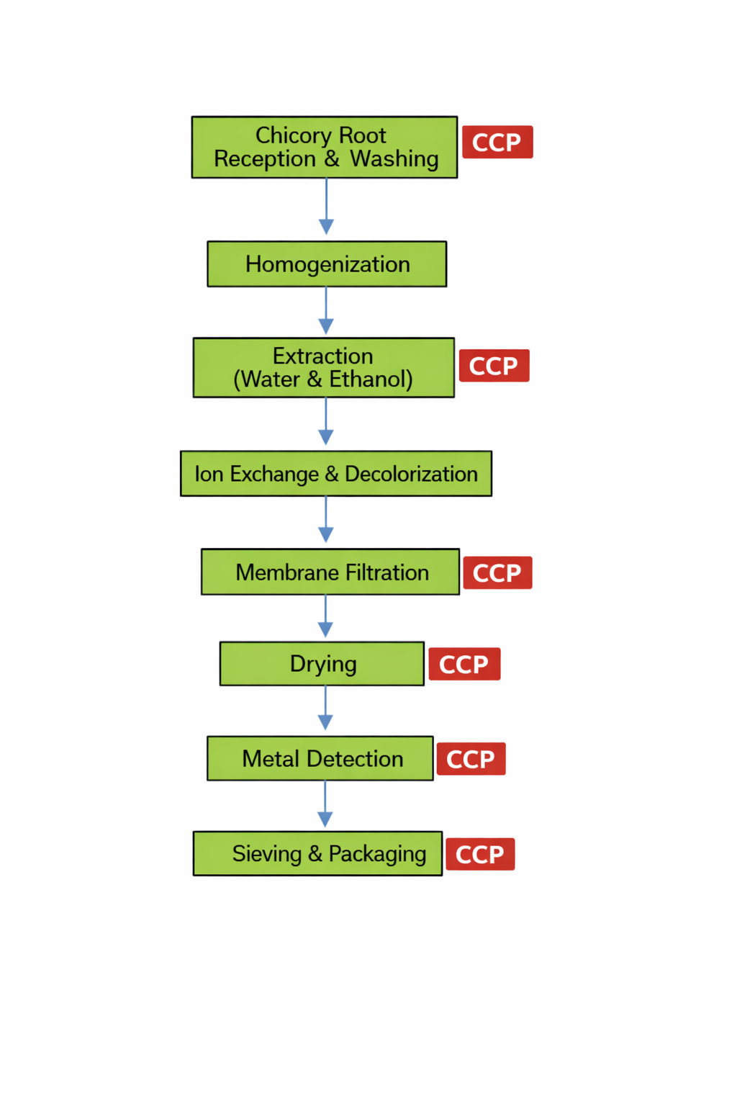
Figure.1 Process Flow chart of inulin power

- Hazard Analysis and CCP Determination
Raw material Decision tree:
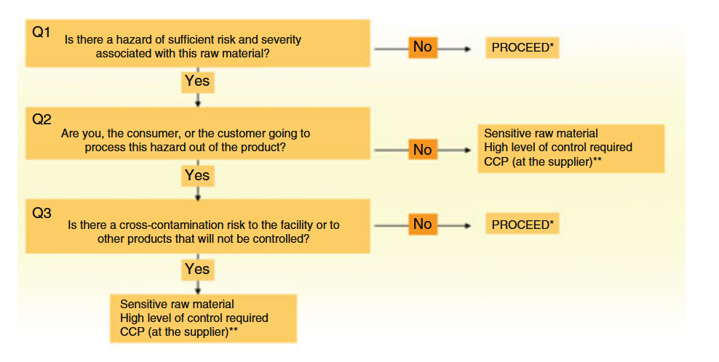
Figure.2 Raw material decision tree
Table.1 Raw material hazard analysis
Raw material | Hazard | Q1 | Q2 | Q3 | CCP required? | comment
Chicory Roots &(Jerusalem artichoke) | Biological | yes | yes | yes | yes | The primary concern involves pathogenic bacteria such as Salmonella, Listeria monocytogenes, and Escherichia coli
 | Chemical | yes | yes | yes | yes | This category includes potential pesticide residues (e.g., herbicides and fungicides), as well as the accumulation of heavy metals such as Lead (Pb), Cadmium (Cd), Mercury (Hg), and Arsenic (As).
 | physical | yes | yes | yes | yes | The most frequent hazards are field-related foreign objects, including stones, soil clumps, and grit that can damage slicing machinery or bypass initial washing.

- Hazard Analysis and CCP Determination
Step | Hazard | Q1 | Q2a | Q2b | Q3 | Q4 | Q5 | CCP required? | Comment
Receiving | Biological | yes | no | yes | yes | no | yes | no | Raw milk may contain pathogenic bacteria (e.g., Salmonella spp., Listeria monocytogenes, E. coli). These will be effectively eliminated by subsequent pasteurization (CCP2). Therefore, receiving is not a CCP for biological hazards.
 | Chemical | yes | yes | / | / | / | / | yes | Antibiotic residues (β-lactams), aflatoxin M1, and heavy metals cannot be removed by any later process step.
 | physical | yes | no | yes | yes | no | yes | no | Metal fragments, soil particles, etc. These can be removed by subsequent filtration step. Therefore, receiving is not a CCP for physical hazards.
Storage | Biological | yes | no | no | yes | yes | / | no | Psychotropic bacteria may grow if temperature abuse occurs. However, cold storage alone cannot reduce hazard to acceptable level; pasteurization will eliminate pathogens.
 | Chemical | no | / | / | / | / | / | no | /
 | physical | / | / | / | / | / | / | no | /
Filtration | Biological | yes | no | no | yes | yes | / | no | Filters may harbor microorganisms if not properly cleaned. Pasteurization will eliminate them.
 | Chemical | no | / | / | / | / | / | no | /
 | physical | yes | no | yes | yes | yes | yes | no | Filter screens may break, allowing particles >2mm to pass. However, subsequent metal detection (CCP4) can detect metal fragments, and visual inspection for other large particles.
Standardization | Biological | yes | no | no | yes | yes | / | no | Mixing tanks may be contaminated. Pasteurization will eliminate hazards.
 | Chemical | yes | no | no | yes | yes | / | no | Incorrect addition of ingredients could lead to chemical hazards. Controlled by recipe verification, calibrated scales, and double-checking.
 | physical | no | / | / | / | / | / | no | /
Pasteurization | Biological | yes | yes | / | / | / | / | yes | Pathogens must be destroyed.
 | Chemical | no | / | / | / | / | / | no | /
 | physical | no | / | / | / | / | / | no | /
Cooling | Biological | yes | no | no | yes | yes | / | no | If cooling is insufficient, surviving spores may germinate. Cooling to ≤4°C slows growth.
 | Chemical | no | / | / | / | / | / | no | /
 | physical | no | / | / | / | / | / | no | /
Aseptic filling | Biological | yes | yes | / | / | / | / | yes | Recontamination during filling.
 | Chemical | yes | no | yes | yes | no | yes | no | Chemical migration from packaging or cleaning agent residues. Controlled by supplier certification (food-grade materials) and validated rinse cycles.
 | physical | yes | no | yes | yes | yes | / | no | Packaging defects. Metal detection (CCP4) after filling can detect metal; visual inspection for defects.
Packaging and labeling | Biological | yes | no | no | yes | yes | / | no | Post-filling contamination is unlikely if package integrity is maintained. Visual inspection for seal integrity.
 | Chemical | yes | no | no | yes | yes | / | no | Label adhesive or ink migration unlikely. Controlled by food-grade material certification.
 | physical | yes | no | no | yes | yes | / | no | Packaging defects. Visual inspection.
Metal detection | Biological | no | / | / | / | / | / | no | /
 | Chemical | no | / | / | / | / | / | no | /
 | physical | yes | yes | / | / | / | / | yes | Metal fragments from equipment wear or previous steps.
Storage | Biological | yes | no | no | yes | no | yes | no | Temperature abuse may allow psychotropic growth. Controlled by continuous temperature monitoring and alarms.
 | Chemical | no | / | / | / | / | / | no | /
 | physical | no | / | / | / | / | / | no | /

- HACCP control chart
CCP no. | Process step | Hazard | Control measure | Critical limits | Monitoring |  |  | Corrective Action
 |  |  |  |  | Procedure | Frequency | Responsibility | Procedure | Responsibility
1 | Receiving | antibiotic residues (β-lactams), aflatoxin M1, heavy metals | Supplier COA verification  Rapid antibiotic testing  Aflatoxin M1 analysis  Transport temperature check | Antibiotics: negative  Aflatoxin M1: ≤0.3 μg/kg  Transport temperature: ≤4°C | Review COA and test results  Perform rapid antibiotic test  Collect sample for aflatoxin analysis  Check temperature recorder chart | Every tanker load | Quality Control Technician | - If antibiotics positive: reject batch, quarantine, notify supplier, investigate source  - If aflatoxin >0.3 μg/kg: reject batch, reassess supplier  - If temperature >4°C: check duration; <2h = downgrade to industrial use; ≥2h = condemn | QC Supervisor and QA Manager
2 | Pasteurization | survival of pathogens (Salmonella, Listeria, E. coli) | Automatic temperature control  Time control  Flow diversion system | Temperature: 72–75°C  Time: 15–20 seconds | Continuous chart recorder  Visual check of temperature display every 15 minutes | Continuous; operator check every 15 min | Production Operator (verified by QC) | - If temperature <72°C or time <15s: automatic divert, stop production  - Isolate affected product since last valid reading  - Investigate cause (steam valve, probe)  - Recalibrate equipment  - Re-pasteurize or test affected batch before release | Production Manager and QA
3 | Aseptic Filling | post-pasteurization recontamination | Sterilization of packaging materials  CIP/SIP of filler  Positive air pressure  Environmental monitoring | Packaging surface: ≤10 CFU/100cm²  Airborne count: ≤30 CFU/plate/30min  CIP parameters: alkali 1.2–1.5%, 80–85°C, 20 min | Swab test packaging materials  Settle plates for air  Check CIP recorder | Packaging: every 4 hours  Air: pre-, mid-, post-production  CIP: each batch | Microbiologist / QC Technician | If packaging >10 CFU: stop filling, repeat CIP with extended acid cycle, increase disinfectant (NaOCl from 200 to 300 ppm), retest  If air >30 CFU: stop filling, ozone treatment (30 min), check room seals and HEPA filters, re-monitor  If CIP deviation: repeat cleaning, verify before resume  Quarantine affected product | QA Manager and Production Manager
4 | Metal Detection | metal fragments from equipment wear or raw materials | Metal detector with auto-reject  Regular sensitivity checks | Ferrous (Fe): ≤1.5 mm  Non-ferrous (non-Fe): ≤2.0 mm  Stainless steel: ≤2.5 mm | Pass products through metal detector  Test with reference pieces | Continuous; test pieces every hour | Production Operator | If metal detected: auto-reject, isolate rejected packages, investigate source  If test piece fails: stop production, recalibrate, re-test all products since last valid test  Repair or replace faulty detector  Report to Production Manager and QA  Document all rejections and corrective actions | Production Manager and QA

- Documentation and records
All monitoring activities are documented on standard forms. Records include raw milk test results, temperature charts, CIP logs, packaging material test results, air monitoring data, and metal detector checks. Corrective action reports describe the problem, action taken, and follow-up. These records are kept for at least three years, with corrective action records retained for five years.
- Verification
Verification activities are essential to confirm that the HACCP system is operating effectively and in compliance with the established plan. The verification programme for our pasteurized fresh milk production includes internal audits, external audits, GMP audits, as well as routine calibration, product testing, and record review.
1. Internal Audit
Internal audits are conducted annually by the company’s trained internal audit team, independent of the areas being audited. The audit covers all HACCP-related activities, including CCP monitoring records, corrective action documentation, PRP implementation, and employee training.
- Scope: Entire production process from raw milk receiving to distribution, as well as supporting programmes (cleaning, maintenance, pest control, etc.).
- Frequency: Once per year, with additional audits if significant changes occur (e.g., new equipment, new product).
- Audit team: Composed of QA manager, production supervisor, and a trained internal auditor from another department.
- Audit findings: In the most recent internal audit (2025), one minor non-conformance was identified: incomplete temperature records for cold storage on two occasions. The corrective action included retraining of warehouse staff and implementation of a digital temperature monitoring system with automatic alerts. Follow-up verified effectiveness.
- Records: Internal audit reports, corrective action plans, and follow-up verification records are retained for 5 years.
2. External Audit
External audits are performed by accredited third-party certification bodies to verify compliance with international food safety standards. Our facility is certified under FSSC 22000, which includes ISO 22000:2018 and sector-specific PRPs (ISO/TS 22002-1).
- Certification cycle:
  - Initial certification audit (every 3 years)
  - Surveillance audits (annually in the intervening years)
- Audit scope: Full assessment of the food safety management system, including HACCP plan, PRPs, traceability, recall procedures, and management review.
- Recent outcome: In the 2025 surveillance audit, the certification body confirmed that all CCPs were effectively controlled, and no major non-conformities were identified. One observation was made regarding the need for more frequent verification of aseptic filler environmental monitoring, which was addressed by increasing air sampling from three times daily to four times daily.
- Records: External audit reports, certificates, and any corrective action responses are maintained by the QA department and available for review.
3. GMP Audit
Good Manufacturing Practice (GMP) audits are conducted monthly by the QA team to ensure that basic hygiene and operational conditions meet regulatory and company standards. These audits focus on:
- Personnel hygiene: Proper handwashing, use of hairnets and protective clothing, absence of jewellery.
- Facility and equipment: Cleanliness, maintenance, absence of pest activity, proper waste disposal.
- Operational practices: Correct handling of raw materials, adherence to cleaning schedules, proper storage conditions.
- Documentation: Availability of procedures, completed cleaning logs, temperature records.
- Review
The HACCP plan is subject to review under the following circumstances:
- Change of government legislation or guidelines
e.g., new safety limits for antibiotic residues in raw milk, updated standards for aflatoxin M1, or revised microbiological criteria for pasteurized milk.
- Outbreak of a food safety incident involving the product
e.g., a product recall due to pathogen contamination, or a public health alert linked to pasteurized milk.
- Consecutive complaints on product safety or unstable product quality
e.g., repeated customer complaints about off-flavours, spoilage, or foreign matter, indicating possible process drift.
- Introduction of new formulation or production technology
e.g., change in raw milk sources, addition of vitamins or probiotics, or installation of new pasteurization or filling equipment.
- Change of equipment, packaging materials, or methods
e.g., replacement of the pasteurizer, introduction of new packaging materials (different supplier or material type), or modification of the CIP procedure.
- Emergence or detection of new foodborne pathogens or other hazards
e.g., identification of a new pathogen of concern in dairy products, or new scientific evidence regarding previously unrecognized chemical hazards.

